* Download SpeedAC iQ Checkweigher Vx.x.x.SFW application (from iQ Knowledge base)
  + Checkweigher license
    - Verify if license into Service Mode – License - ‘Check E dyn’ is valid
    - If NOT valid, get the license code from the SpeedAC iQ Registration Database
    - 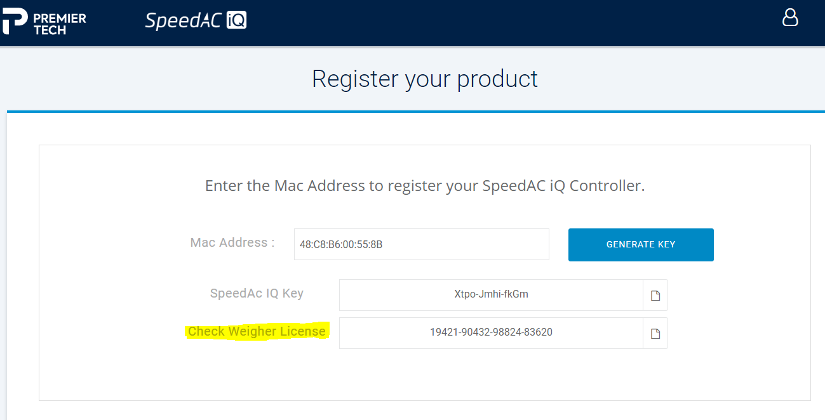
  + Configure IOs corresponding to electrical drawing
  + Run conveyor with IO test screen and measure Belt speed
* Calibrate Scale : must be done during the JunctionBox shift adjust procedure of the summing board

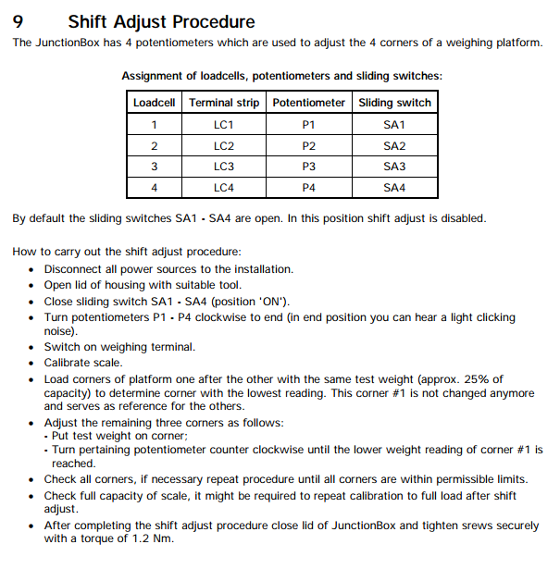

Service Mode Calibration parameters :

* Calibration – 1 Parameters

|  |  |  |
| --- | --- | --- |
| Calibrated in “kg” | | |
| Load cell capacity | 4 x 50kg | 4 x 100kg |
| Single Range | | |
| One Interval | | |
| Capacity | 30 | 60 |
| Interval | 0.01 | 0.02 Dynamic Mode |
| Unit | kg | kg |

* Calibration – 5 Adaptation (*Basic parameters*)

|  |  |  |
| --- | --- | --- |
| Motion Window | 0.5D |  |
| Motion Counter | 20 | Not use in Dynamic Mode |
| Filter size | 11 | Not use in Dynamic Mode |
| Auto Zero Range | 0.5D | Not use in Dynamic Mode |
| PbZero(%)+ | 2 |  |
| PBZreo(%)- | 2 |  |
| PowerUp Zero | OFF |  |
| Overload | 9 |  |
| Incline Switch | OFF |  |
| Underload 20d? | N | Not use in Dynamic Mode |
| With Taring? | Y |  |
| Onscreen typeplate | N |  |
| Update Rate | 225 | Not use in Dynamic Mode |

* Calibration – 5 Adaptation (*Check parameters*)

|  |  |  |
| --- | --- | --- |
| Check Dyn. Cal. |  |  |
| Approved | Y |  |
| Catchweigher | N |  |
| Dynamic mode | Y |  |
| Dyn.rate[Hz] | 429 |  |
| Min.zero t.[s] | 0.3 |  |
| Dyn.AZ mode | Auto |  |
| Dyn.AZ per.[min] | 15 |  |
| Max.meas.t.[ms] | 2000 (Adjust to travel time) | Enter Travel time between sensors[ms]:  Metric: Lenght[mm] / Speed[m/s]  Imperial: Lenght["] / Speed[FT/min] x 5000 |
| Start mode | LB N/O or LB N/C | Select Start mode:Triggered by Entry Photocell  N/O if signal is ON when object detected  N/C if signal is OFF when object detected |
| Stop mode | LB N/O or LB N/C | Select Stop mode:Triggered by Exit Photocell  N/O if signal is ON when object detected  N/C if signal is OFF when object detected |
| LB deb.t.[ms] | 50 (recommended value) | Photocells Debouncing Time (10-100[ms]) |
| Warm up time[min] | 0 |  |
| Min.load[d] | 300 | From W&M certificate - in Dynamic mode Class III |
| Tr. control | Stop |  |
| Speed control | Stop |  |
| Speed Tol.+[%] | 5.0 |  |
| Speed Tol.-[%] | 5.0 |  |
| Speed dist.[mm] | 1372 | Enter Distance between Photocells in mm (" x 25.4) |
| Ev. control | Push | Weighment will be considered Invalid |
| Off-dist.[mm] | 0 | Enter Distance FROM "Exit Photocell" TO "conveyor end" - in mm (" x 25.4) |

* SpeedAC iQ Checkweigher parameters :
  + MP Belt Speed (m/s = FT/min / 196.8504)
  + WP Bag Length (mm = INCH * 25.4)
  + WP Tolerance values (Customer will re-adjust)
  + Use the Auto-Tune function to test the filled bags and find the needed Filters (under construction)
* Use PC Check software to monitor weighing curves as needed or run Wizard to adjust the Filters for a different bag lenght(use only if necessary)